Federation Of Muslim Women Association in Nigeria (FOMWAN) and its Activities in Osogbo, 1991-2018
Mohammadtaofeek Suliyat Olajumoke. Department Of History and International Studies
Fountain University, Osogbo, Osun State, Nigeria
msolajumoke.fountainuniversity@gmail.com 07035136502.
Abstract
The globe is replete with a plethora of sociocultural institutions. However, a significant part of them exude patriarchy and as such makes female-oriented ones scarce or irrelevant. That female-induced and focused institutions oftentimes grapple with financial, numerical and leadership challenges because their acceptability is limited compared with their male counterparts lends credence to the afore. Despite this popular anomaly, women have displayed their resilience and diligence in various manners especially in the formation and propagation of institutions that exclusively encompass female affairs. Of great surprise is that religious-related ones thrive alongside secular ones - this appears like misrepresentation of facts until one delves into the structure, trajectories, and activities of the Federation of Muslim Women Association in Nigeria (FOMWAN) in Osogbo, Osun state, Nigeria. The organization has existed and thrived for more than three decades and its sustainability buoys a lot of intricate dynamics especially viewing via the lens of sister organization. It is on this basis that the evolution and activities of Federation of Muslim Women Association in Nigeria (FOMWAN) and this paper becomes relevant. This paper thus examines Federation of Muslim Women Association in Nigeria (FOMWAN) and its activities in Osogbo between 2001 and 2018; articulates the impediments smothering its missionary enterprise in Osogbo; and highlights the impact of FOMWAN in Osogbo especially in the areas of religion and education, among others. Using historical research methods, the primary source entails oral interviews with relevant stakeholders while articles from journals, newspapers, and books constitute the secondary source. The basic finding is that a lot of developments have been attained through the establishment of FOMWAN and its proliferation in Osun State.
Keywords: Trajectories, Buoys, Pundits, Anomaly, Resilience
Introduction
Women’s advocacy, rights, education, and social welfare have oftentimes been consigned to neglect due to the absence of a viable organization that could assert a profound impact amid detractions and oppositions from diverse quarters. With the primary aim of empowering women and breaking barriers, a lot of institutions have emerged at various points in time. However, the trends of masculine dominance has often suppressed them.
Be that as it may, there are a few surviving ones, and one of such is the Federation of Muslim Women Association in Nigeria (FOMWAN) which has played a pivotal role in the upliftment of women in Osogbo, Osun state, Nigeria. FOMWAN has been a beacon of support and advocacy for women's course in Osogbo. Since its inception in 1991, FOMWAN has been at the forefront of championing gender equality, education, and social welfare initiatives, aiming to create a more inclusive and equitable society. One of the key objectives of FOMWAN in Osogbo has been to enhance the educational opportunities for women and girls. Through scholarships, vocational training programs, and awareness campaigns, FOMWAN has worked tirelessly to promote education as a means of empowerment and social upliftment. By focusing on education, FOMWAN has not only helped women gain knowledge and skills but has also contributed to breaking the cycle of poverty and inequality in the community. In addition to education, FOMWAN has been actively involved in community development projects in Osogbo. The organization has initiated various programs aimed at improving healthcare access, sanitation, and infrastructure in the region. By collaborating with local authorities and stakeholders, FOMWAN has been able to implement sustainable development projects that have enhanced the quality of life for residents of Osogbo.
Furthermore, FOMWAN's advocacy efforts have been instrumental in raising awareness about important social issues and promoting gender equality in Osogbo. Through workshops, seminars, and public campaigns, FOMWAN has been a vocal proponent of women's rights and has worked towards eliminating harmful practices and stereotypes that hinder women's progress. By fostering a culture of inclusivity and empowerment, FOMWAN has paved the way for a more equitable and just society in Osogbo. In essence, the Federation of Muslim Women Association in Nigeria (FOMWAN) has been a beacon of hope and progress in Osogbo by championing women's rights, education, and community development.
Evolution of FOMWAN Missionary Enterprise in Osogbo
FOMWAN is an Islamic mission motivated by the impact and success of other similar missions organized in the past. FOMWAN is an association strategized towards the continuing sustenance of social accounting and services in the society in this our age and the circumstances which we had found ourselves. FOMWAN was established with the strategy to create self- awareness among women in order to be able to identify their constitutional rights and faction ways of protecting the rights as applicable in other communities of the world¹. The emergence of FOMWAN as a women Islamic mission is not the first of its kind in Nigeria, the formation followed the footsteps of similar missions that existed in the past such as "YAN TARU ISLAMIC MISSION². Muslim women were never pushed over in terms of organizing their fellow women to pursue similar objectives of attaining equity, justice and progress for themselves. Islamic mission and /or associations were encouraged by Uthman Dan Fodio during his Jihad or "holy war’’ against the Habe rulers of Hausaland from 1804.³ Dan Fodio, for the promotion of Islam, decided to move beyond Islamic "primitivism" to Islamic "reformism". He disagreed with some Islamic teachers, then, who restricted themselves to the ideology of Islamic primitivisms of people who wished to restore the kind of situation that had existed since the time of the holy prophet and the first four caliphs. He reasoned that while these people restricted themselves to the issue of the past, they were not considerate of what the future and the effect of modernization as well as economic changes would bring to bear on the religion.⁴ Consequent upon this, Dan Fodio and his daughter, Nana Asmau, established "Jaji" female teachers’ group in the early 19th century. Members of Jaji include Dan Fodio's daughter, Nana Asmau and other prominent women; and they contributed to the internationalization of women's education in West Africa during the jihad of Dan Fodio in 1804, especially women convert. In order to avoid Islamic primitivism, women were instituted as part of Islamic reforms in West African states during the time of Uthman Dan Fodio.⁵
However, following the success of Jaji in bringing women to the limelight through their Internationalization of women's education in West Africa, it was obvious that enough enlightenment has been created for Muslim women to empower themselves and also practice their religion without bias. This situation, however, led to the formation of the first ever Islamic women socio-political organization known as the "YAN TARU ISLAMIC MISSION". The founder was also the same daughter of Uthman (Nana Asmau)⁶. Oladejo observed that:
Yan Taru was prominent during the era of Mohammad Bello
(1817-1837), when Asmau Organised its activities across
West Africa and by implication. The movement became
globalised and institutionalized in the American Context
to suit modernization .⁷
Furthermore, " Yan Taru " mission headed by Nana Asmau was part of the reforms initiated by Dan Fodio to discourage Islamic primitivism and encourage women to live up to their religious billings. Women were conspicuously crucial to the success of the reform. Beyond Africa, Yan Taru movement has been recreated in scholarly debates and often taken to be platform that understand Muslim feminism in West Africa. After the death of Asma'u, who was the first leader, another daughter of Dan Fodio, Maryam Bin Uthman Fodio, became the second international leader of "Yan Taru"⁸. Other associations in the 20th century which also served as motivation for FOMWAN included the "Ahmadiyyah Girls Guide Association" formed in 1929 when Mariam Fanimokun gathered together some young girls to form the association. Some of these girls included Sabitiyu Jibril, Rasheedat Issa Williams, Wosilat Wilson Shonibare, and Sikirat Ayeni among others. The activities of the mission motivated and significantly encouraged Muslim women to come together to pursue their common goals and objectives. The association was conditioned to operate under the supervision of Ahmadiyyah Missionary Board and their activities were to be reported to the executive committee of Ahmadiyyah⁹.
However, Some Yoruba Muslim market women were also significant to the development of the status of Muslim women in Yorubaland. Muslim market women in Ibadan who were traditionally known for the formation of traders guilds also helped constitute a strong Muslim women association. For instance, in the 1930s, Humani Alaga gathered together some Muslim market women colleagues to found the Issabatudeen Women Society¹⁰. The objective behind the mission was to be able to unite Muslim women who would be able to speak with one voice. This was also in attempt to create strong footing for Islam in Yorubaland by ensuring a better future for Muslim children through education. Education for the girl child was given priority by the association.¹¹ Consequently, the Muslim students society of Nigeria was formed in 1954 by fourteen Muslim students in Lagos.¹² Among other things, the association created significant impact on Muslim across Nigeria. Consequently, Muslim sister's organization ( MSO ) was formed in the Northern Nigeria in 1964 ¹³. This association subsequently becomes the bed rock for the emergence of FOMWAN. Muslim Sisters Organization later collaborated with some Muslim women from the South west, and metamorphosed into FOMWAN in the 1980s. Federation of Muslim Women Association of Nigeria (FOMWAN) officially came into existence in 1985.As an interface between politics and religion. It was conceived as an avenue which would allow Muslim women the opportunity to express their association was facilitated through the reformative space that was allowed them by Ansarudeen society which afforded Muslim women the opportunity to partake in Islamic activities outside their home. As a result of this, prominent female members of Ansarudeen women's wing formed FOMWAN. From inception, FOMWAN stood out as an agent of change to improve women and children in term of education, health provision and socialization. It is an elite's contribution to the development of Islam in Nigeria. Significantly, educated women who became involve in the foundation of this association were majorly product of western education that was offered in the formal school system.¹⁴
FOMWAN was formed from the efforts of some thirty six educated Muslim women elites. This group of women wished to discover and engaged the services philosophy of Islam as a tool for empowering women. They strongly wished to employ their acquired experience over time as the means of creating positive influence on the women folk. The idea of these women is to stand against, and also condemn in its totality the deplorable status of women and their poor educational status. These women being members of the Ansarudeen society were significantly motivated by the educational philosophy of the Islamic society. ¹⁵ From inception, education has always been the vision of Ansarudeen society and the inclusion of women was protected in their policy.
Consequent upon the above, these thirty-six prominent Muslim women of the Ansarudeen women's wing gathered themselves together in Minna, Niger State at the Islamic education trust to form FOMWAN in 1985. Notable among these founders include late Hajia Lauret Sada, a lecturer at the Faculty of Science Ahmadu Bello University, Zaria. Also, there was the first Amirah of FOMWAN, Hajia Aishat Bridget Lemu, she was an inspiration to the group. Aishat Lemu was a Briton who had to convert to Islam after her marriage to a Nigeria Islamic cleric-sheikh Ahmed Lemu. There was another woman, Alhaja Lateefa M.Okunu. She was a representative from Lagos who studied Geography at the University College in London in the early 1960s. Similarly, we have Hajiya Saadiya Omar Bello, Khairat O. Sodique, Hajiya Balikisu Yusuf Alaga (Dr), Lateefah Durosimi and many others.¹⁶ The mission is a non-profit making, non-governmental organization consisting of a body of Muslim women associations in Nigeria to empower women to be role models in contributing positively to the economic and social development of women in Nigeria. After its inauguration, FOMWAN was registered with the Corporate Affairs Commission in the same year, 1985.¹⁷ Importantly, members intended to propagate the religion of Islam through Da'wah, encourage women education and creation of other avenues which will enhances the socio-economic development of the people of Nigeria. Some of these include; Establishment of schools, Provision of healthcare facilities, Trainings, Human services, Micro-enterprise scheme, Advocacy and many others.¹⁸
Furthermore, after the inauguration of FOMWAN in Minna, Niger State in 1985, the mission started operation with the following aims and objectives:
- To create awareness among Muslim women of the true teachings of Islam in the Quran and Sunnah, and to encourage women to live in accordance with those teaching
- To promote and propagate the cause of Islam in Nigeria and beyond
- To make positive impacts on national matters both religious and secular with a view to safeguarding the interest of Islam.
- To unite and coordinate Muslim women organizations in Nigeria so as to enable them to speak with one voice, by acting and making decisions together.
- To serve as liaison between Muslim Women and the governments. (Federal, State and Local governments).
- To do away with sectarian, ethnic, and other divisive factors among Muslim women in all parts of Nigeria.¹⁹
Aside these aims and objectives, the main goals are directed towards the following:
- Improving the moral and intellectual development of women, youth and children.
- Improving the general health status of women, children, and youth.
- Empowering women, youth, and children through skills acquisition and other
financial and material support, and training for sustainable development.
- Enhancing the level of understanding of the teachings of Islam amongst the "Ummah'.
- Continuing to influence and effect positive changes in policies and issues that
affect women, youth and children as well as the religion of Islam. Improving the social and economic services in identified communities
- Lastly, continuing to mitigate the impact of disasters and distress on affected persons.²⁰
Furthermore, different State branches began to move away establishing their state chapters of the mission. However, the Osun State branch of the mission only emerged after the creation of Osun State on August 27,1991. ²¹ Subsequently, the Osun State Branch of FOMWAN was inaugurated in November 1991 but did not start activities until 1992. At the time of its establishment, members of the association were drawn from old Oyo State.²² It is important to note that FOMWAN operates under 3 major tiers, the National level, State level and Local government level. FOMWAN therefore commenced their activities in Osogbo under the leadership of Alhaja Silifa Balogun, who tried all her best to ensure the survival of the mission. She was ably supported by other members such as Late Alhaja Sikirat Adewusi, Dr Mrs Lateefat Durosinmi and many others. However, as fate would have it Alhaja Silifa Balogun eventually became the Osun State first Amirah of FOMWAN. She served for two term tenure of four years and was succeeded by Alhaja Sikirat Adewusi of Ilesa who is now late. Alhaja Sikira was succeeded by Alhaja Latifat Giwa who was also succeeded by Dr. Mrs Lateefat Durosimi. Dr Durosimi is a Lecturer at Obafemi Awolowo University Ile-Ife. She was later appointed as the National Amirah of FOMWAN after her tenure as Osun State Amirah of FOMWAN. 22
Consequent upon this development, Dr Durosinmi's deputy Alhaja Naibatu Amidalat Adewoyin was appointed as the Osun State Amirah of FOMWAN. Alhaja Kudirat Nofiu became the State Amirah after Amirah Amidalat completed her four year tenure. The seventh state Amirah was Alhaja Suwebat Tolani Babalola Adubi, the principal of Muslim middle school, Osogbo. She was succeeded by Alhaja Kudirat Olabimpe who is the incumbent Amirah of FOMWAN of Osun State.²³ Osogbo local government branch of FOMWAN was also established in 1991 and started operation when the State branch started operation in 1992. This implied that the local government branch was simultaneously established alongside that of the state chapter. The inauguration took place at the then Osun State House of assembly complex at Olonkoro, Osogbo. Today, the Osun State branch of the mission remains the 34th states branch in Nigeria where FOMWAN has been established. Similarly, the Osogbo /Olorunda local government chapter is one of the 50 local branches operational in Nigeria. ²⁴ FOMWAN in Osogbo/ Olorunda was formed on the belief that their local interests can be addressed through carefully coordinated and experienced personalities with the fear of God. These are the people who could help sustain their policy objectives through their Islamic principles, its interpretation as well as dynamism towards solving local problems.²⁵ Many notable Muslim women most of who have been very formidable with existing missions constituted the bulk of membership of Osogbo FOMWAN. They all worked religiously and devotedly with the first Amirah of the local government chapter, Alhaja Sidikat Daodu. She was succeeded by Alhaja Amdalat Agboola who after her four years tenure handed the batton ofleadership to Amirah Alhaja Kudirat Nofiu. After which Alhaja Omoriyeba (now late) took over the office. Alhaja Silifat Akintayo took over after the demise of Omoriyeba, and was succeeded by the present Amirah Alhaja F.O Uzamot.²⁶ The administrative structure ofOsun State and Osogbo FOMWAN follows the same organizational structure as stipulated in the national constitution of FOMWAN.
Furthermore, the post of the Amirah, Naibatul Amirah, and Secretary, Assistant Secretary, Financial secretary, Treasurer, Dawah officers and Assistants are selected to help champion the developmental aspirations of the mission. Similarly, communities were constituted to formulate plans and supervise projects under the zone in order to be able to achieve desired results. Members of the local government executives work hand in hand with that of the State that may also function as members of the national executives to form a formidable operational chain who have been keeping FOMWAN mission effective since the commencement of its operation in 1992.²⁷ The constitution of boards and or working committee is very crucial to the success of FOMWAN. In Osogbo, FOMWAN started with ad-hoc committee members but it was later transformed to standing committees. Presently different committees and boards have been constituted. These include Orphanages committee, Education, Health project, Finance, Welfare/social, Membership drive, Business venture, Transport, Youth camp, Guidance counseling committees etc. Each of the committees is headed by chairperson who gives report at every meetings or whenever the need arises. The chairpersons of committees as well as the local government Amirah may also be part of the State executive council.²⁸ In all the 34 states of the Federation where FOMWAN could be found, their funds are kept in various banks. However, the National headquarters uses Keystone Bank as its bank in Abuja, Osogbo, Kaduna and Lagos state. In order to continue to keep the mission afloat, its account is regularly audited. The organization can conveniently boast of many fixed assets, ad-hoc staff and others. Significantly, FOMWAN is currently not liable to any individual or organization.²⁹ FOMWAN Osogbo secretariat is located at Abioye Moremi Street, Ayedun Estate, Old Governor's office, Gbongan/Ibadan Expressway, Osogbo.
FOMWAN Mission and the Propagation of Islam in Osogbo
FOMWAN, particularly in Osogbo has been trying to use the positive impact of education to propel the development and the spread of Islam. The group is of the view that people who lack modern education are ignorant of many things. FOMWAN does not belief that Islam is a barrier to educational achievements, or vice versa. Instead there may be barrier to the spread of Islam when the women themselves are not educated. Therefore, educational opportunities have been made available to both youths and adults who are saddled with the responsibility of the propagation of Islam by sending them to Islamic Institution within and outside Nigeria. There are series of youth and adult educational opportunities introduced by FOMWAN to enhance the communicative ability of Muslim women and to boost their courage in defending Islamic ethics such as weekly lecture series that comes up every Sunday evening at the mission secretariat. Osogbo FOMWAN offers adult literacy programmes for women, especially in English language. In addition, they established women Islamiyyah literacy school and Vocational training centers. These help to enhance the status of Muslim women in Osogbo and Osun State. This has been a motivation for other women and new converts. Today, the mission can also boast of many important and useful Islamic literatures essential for the teaching of Islamic studies in schools, such as: "Essentials of Islamic Studies BK ,1 BK 2 and BK 3 for junior and senior secondary schools by Aisha Lemu", "Islamic Studies for senior Secondary Schools BKI, BK2, BK3 by Aisha Lemu'. ³⁰ Most of these books have been authored by FOMWAN leaders such as Dr Mrs Lateefat Durosinmi. Some of the important ones are used in many Islamic schools for the teaching of Islam has been produced by the founder and the pioneer Amirah of FOMWAN, Hajia Aisha Bridget Lemu. Her works have been good recommended for many Islamic schools as the means for promoting the best Islamic behaviors in our modern day Muslim societies.³¹
Furthermore, it is important to note that FOMWAN does not operate weekly Asalatu groups but they partner with other Muslim groups such as: NASFAT, NACOMYO, QUAREEB, etc. that engage in weekly Asalatu to carry out evangelism across the town. It is also important to note that through collaborations with some of these groups FOMWAN has contributed immensely to the growth and development of Islam in Osogbo through sponsorship of Tafsir and Iftar programmes during Ramadan, Donation of Islamic relief materials and funds to student of Arabic and Islamic studies across Madrasah (Islamic schools) in the town. Most of FOMWAN evangelism programmes are targeted at youths and Women.³²
Furthermore, Muslim youths have been substantially encouraged to adopt and value the true essence of Islamic teaching through free Islamic Education given to youths in Osogbo. Quarterly Quranic recitation programme are periodically organized for the youth by FOMWAN. This is to help test the extent of their Islamic/Quranic assimilation and pedagogy is been mastered among the youth. The youths, after the recitation are further encouraged with fascinating rewards in gift items and the offering of scholarships for some of the excellent participants. The objective of FOMWAN is to develop sound future Quranic teachers who will continue to carry on the propagation of Islam in subsequent years. In the same vein, Osogbo FOMWAN organizes annual youth camp for Muslim girls. The idea of which is to keep them closer to Islamic teachings and ethics. This annual event is a week long programme and provides the avenue through which the girls are closely monitored and religiously tutored. Different educative lectures, prayer sessions and several other events are packaged into the programme to bring out the best from them. Their interactions with other youths from different background have proven to be of an instructional advantage to their learning of the Quran and Islamic ideology. ³³
Similarly, the programme is anchored by disciplined and versed Muslim women in Islamic knowledge who can motivate the youths. The anchors themselves are women of virtue who have achieved greatness in their choice area of specialty. Reports from participants indicated that the youth camps had been one of the greatest motivations for Muslim female youths to appreciate and move closer to Islamic practices.³⁴ The local government chapter in collaboration with the state branch publishes and circulate FOMWAN magazine 'THE MUSLIM WOMEN. This is enlightenment medium where very inciting socio-religious and particularly Islamic contents are discussed for the growth of Islam. The magazine is also educative and religious awakening for students and elites alike. The mission strongly prioritizes the celebration of every Islamic festivals in the State. The period of Ramadan is used to encourage the teaching of Islam. During this period, extensive Ramadan lectures are organized. Some of these are aired on the local radio and television stations. Quran education is an important aspect of every Muslim lives, FOMWAN run different after school madrasah across Osogbo where student attend in the evening particularly after school hours to learn Arabic, these schools are free and the teachers are paid and fully sponsored by FOMWAN.³⁵ This is done to propagate Islamic religion in Osogbo.
Challenges of FOMWAN in Osogbo
Since the emergence of FOMWAN, the Islamic mission has been confronted with some challenges. These challenges have attacked the Islamic mission in achieving her mission and goals in Osogbo and its environs. They have a lot of developmental programs such as (establishment of FOMWAN secondary school, construction of FOMWAN central Mosque, proposed FOMWAN tertiary institution etc.) but yet to be accomplished. Some of these challenges are: Financial challenges, Orphanarium neglect, Low level of grass root participation, low level of education among the grass root women, Diversion of attention.
• Financial Challenges: Lack of fund has been a stumbling block to the progress of the mission in Osogbo. Fund used in executing some of their plans are donations coming from members of the association and some well-meaning citizens of Osogbo which is not always enough to channel the developmental plans of the mission. Sometimes the executives are given specific amount of money to donate apart from general donations so as to meet up with some of their itemized plans. Often times, FOMWAN seek for support from the government and other private parastatals which often times they do not get because they are expected to operate as a non-governmental organization that they are. They only get fund from government on occasions when they have members that have direct link of government officials or politicians who could fight for their course.⁴³
Orphanarium Neglect: This is also a major challenge that has been hindering the smooth management of the FOMWAN orphanage home. The orphanage home located in located at Abioye Moremi Street, Ayedun Estate, Old Governors office, Gbongan/Ibadan Expressway, Osogbo is being controlled and managed by both FOMWAN in Osogbo and Olorunda local governments orphanage committee headed by the Amirah. The orphanage committee is responsible for the welfare of the orphanage home and their major challenge is with the people that bring children to the orphanage. They see the orphanage as a dumping site where they could bring children and neglect them there. Once they register and drop the children, they do not bother to check on them. On several occasions, FOMWAN has tried reaching out to some of these people only to discover that most of the contacts information they drop during registration are not traceable. At some point 2014, the mission had to stop admitting children because of financial constraint, accommodation and neglect as discussed earlier for few months. However, some of the grown children of the orphanage are adopted by some of their members after meeting necessary requirements to ease the monitoring of the little and young ones.⁴⁴
• Low Level of Grassroot Participation: One of the objectives of FOMWAN is to create awareness of the true teachings of Islam in the Quran and Sunnah among Muslim women, and to encourage Women to live in accordance with those teachings. The attainment of the above objectives has been defeated because of the low level of participation from the grassroot women in Osogbo despite the sensitization and awareness created by the mission, grassroot women are not motivated and this greatly affected the membership and composition of women as members of FOMWAN, many of the grassroot women prefer to join other Islamic missions that are Alasalatu groups (e.g NASFAT, AL MIZAN, QUAREEB etc.) than joining FOMWAN because the mission does not operate weekly asalatu .⁴⁵
Low Level of Education among the Grassroot People: FOMWANs commitment to both Western and Arabic education led to her increasing campaign on girl child education. FOMWAN leads the process of community sensitization and enrolment drive for both male and female children between age 5-10 within Osogbo and its environs to battle the increase in low turn-out for western education among the grassroot people. Sadly, little progress has been made on this effort due to the high level of ignorance of most of the parents in grassroot on the Importance of girl child education. Value was placed on girl child learning trading or engaging in artisanship than acquiring Western Education. The few ones that are opportune to acquire western education are restricted to some particular courses. This has greatly deteriorates the efforts of FOMWAN towards girl child's education in some ofthese areas. ⁴⁶ However, despite the challenges faced by FOMWAN in Osogbo, the mission did not relent in working towards achieving her goals and mission.
The Impact of FOMWAN in Osogbo
The impact of FOMWAN in Osogbo since 1991 could be seen in different areas. The impact can be categorized into the following areas: Economic Impact, Educational Impact, Political Impact, Health Impact, Humanitarian Services, and Moral Impact.
• Economic Impact: FOMWAN helps women to re-discover themselves and their potentials through empowerment programmes. Many of the organized workshops and empowerment programmes of FOMWAN are targeted at improving the economic status of participants. Economic independence is a sure way of combating poverty which has been the bane of development in every African society. It is as a result of pursuing economic independent for the women of Osogbo that many empowerment training programmes have been organized by FOMWAN. Through these many women are trained to be self-sufficient by introducing them to special trade and catering services such as cakes and snacks making. Some of the women have been trained in the skills of bee keeping, poultry and vocational arts such as bead making, soap making, wire works, bridal fans and many other crafts. In some other instance professional and empowerment machines are donated to women in the local government area. Some of these include sewing machines, grinding machines, refrigerators and others.³⁶ These activities are initiated to benefit women in such a way that they would be of immense benefits to Osogbo and Osun State.
Educational Impact: FOMWAN is of the view that education enlightenment and awareness is the best way of producing peaceful and God fearing individual that are capable of employing their faith as a good source of integration with others. Workshops, seminars or conferences are periodically organized for Muslim women. These are to provide opportunity for them to come face to face with successful Islamic role models whose mission is to give them valuable hints on academic activities that could be essential to make them realize that Muslim women should not diminish their role and status. Instead they need to apply their Islamic wisdom as the means of enhancing the development of the communities where they find themselves. The conferences have been developed to produce God fearing Muslims that could live peacefully with others devoid of fracas.³⁷ " Nigeria is ab-initio the development of its education system. The most potent instruments for the development of human resources are through education. It is in the above regard that Education stands out prominently in many of the ways in which FOMWAN has been trying to contribute to the development of Osogbo and Osun state. The mission has in many ways tried to compliment the efforts of government, private and interested groups by establishing nursery and primary schools as well as secondary school in Osogbo. The schools are not restricted to Muslims alone, but to every child in their locality without bias to tribe and religion. FOMWAN Model Nursery and primary school is situated at Abioye Moremi Street, Ayedun Estate, Old Governors office, Gbongan/Ibadan Expressway, Osogbo. Importantly, the mission also issues periodically, partial scholarships to youths who are excellent in their studies. Currently, Osogbo in collaboration with other branches in Osun State are contemplating the introduction of a FOMWAN higher institution of learning in Osogbo.³⁸ This has been viewed as a way they could positively influence the development of tertiary education in the state.
Picture 1: A picture of FOMWAN Model Nursery and Primary School
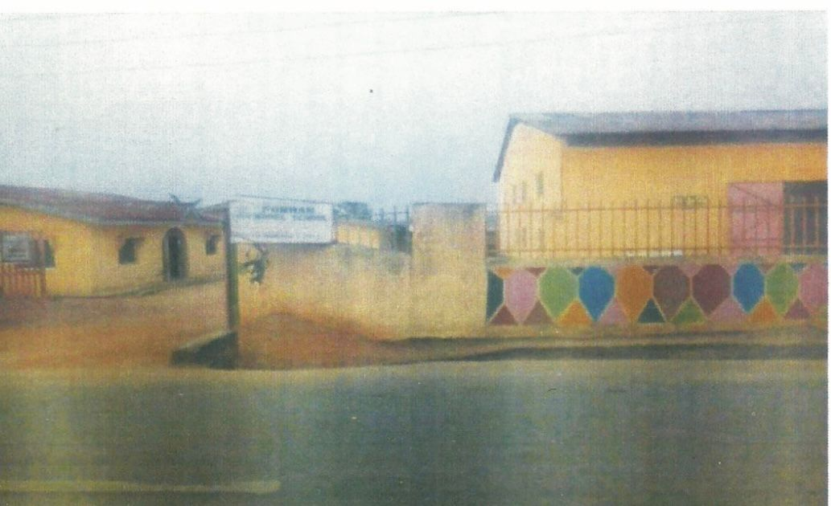

Source: Snapped by the researcher during field work 22/03/2020
Health Impact: FOMWAN in Osogbo aware of the condemnable state of the health care system in the town have been trying to offer assistance within their financial capacity. The health committee visits hospitals to motivate and counsel hospital inmates and offer moderate assistance. Many of the primary health care centers are also visited on regular basis (quarterly). Office equipment, such as bed, chairs, tables, fans etc. are freely donated to these centers to enhance the effectiveness of their service. Similarly, lectures and workshops are frequently organized by the relevant committees where in health-related issues are priority focused. This is to create necessary awareness as a way of reducing the rate of health problems.³⁹
Humanitarian Service: The impact of FOMWAN is also felt in the area of humanitarian services to the people of Osogbo. Aside their visit to the hospitals, their welfare committees also visit the prisons in their area in order to give reformative counseling to the inmates. That is not all, the care and visits to the aged is also paramount in their agenda. Regular visits (monthly) are paid to the aged ones with money and foodstuffs in the town, like wise to the widows and the bereaved as a way of giving them support and encouragement.⁴⁰ One of the major activities of FOMWAN is the running of orphanage which houses abandoned children of different backgrounds, irrespective of religious affiliation. The children are well catered for until they attain the age at which they could re-unite with their families, children who benefit from this gesture include street children who do not have places to go, abandoned ones, and orphans. The orphanage has its own building in FOMWAN secretariat complex with six staffs (6) working on night and day shift, it's been managed with funds solicited from the general public and donations made by members of FOMWAN. In the same vein, provision is also made for youths who dropped out of school or school age children who are not enrolled in schools. ⁴¹FOMWAN orphanage is located at Abioye Moremi Street, Ayedun Estate, Old Governor’s Office, Gbongan/Ibadan Expressway Osogbo.
A picture of Children of FOMWAN Orphanage Home
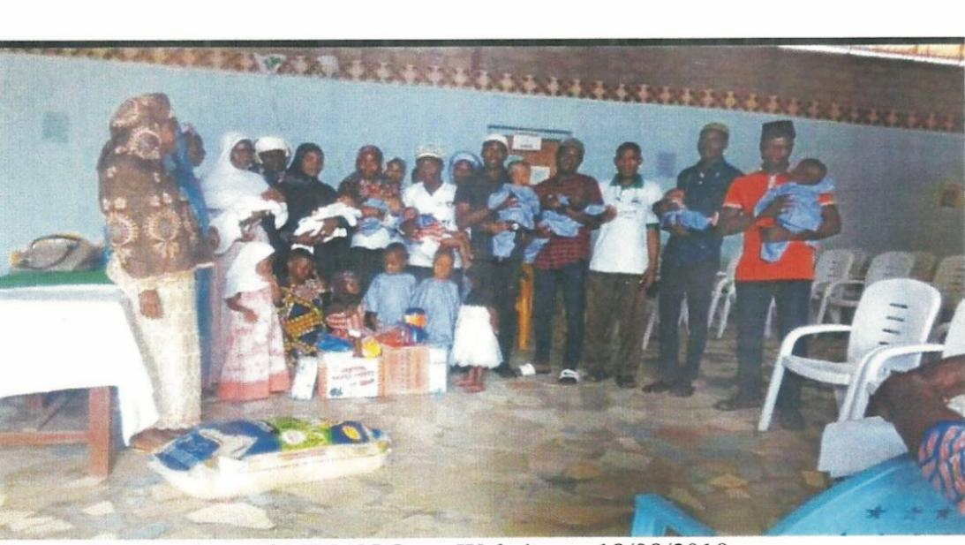
Source: Retrieved on FOMWAN Osun Website on 18/08/2019
A picture of FOMW AN Orphanage Home, Osogbo
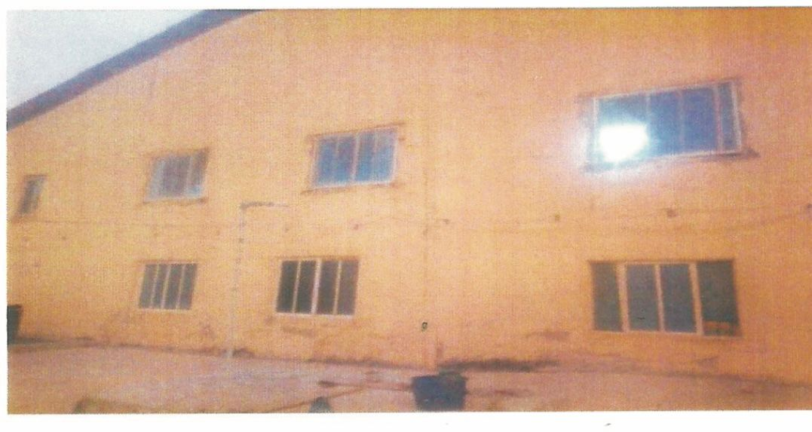
Source: Snapped by the Researcher during field work 18/08/2019

Political Impact: FOMWAN's election and good governance committee was established in 1998 at the National level to explore how to engage with the return of power to civilians after a prolonged period of military rule. During the 1999 transition period FOMWAN members were opportune to monitor elections under the transition monitoring group. In 2007, it contributed its quota to the elevation process by sensitizing people for active participation and dissuaded them from violence ahead of the election through house to house campaign for peace and sponsorship of enlightenment programs on local radios and television. Similarly, in 2011 FOMWAN, like other stakeholders, mobilized people especially their members for the election. The mission has continued in that same capacity ever since members have endeavour to make contributory advances by showing interest for successful political administration in state. FOMWAN has been able to produce women in political offices in Nigeria, this was an opportunity which manifested when Senator Bola Ahmed Tinubu of Lagos State appointed Alhaja Lateefat Okunu as the the Deputy Governor of the State in 1992. Also, a member of the Osogbo FOWMAN Alhaja Lateefat Giwa was appointed as Commissioner for Human Resources and Capacity Building in the State of Osun under the Administration of Ogbeni Rauf Aregbesola as the Governor of Osun State. Her appointment was based on the activities of FOWMAN in the state which could be seen in the area of capacity building. ⁴² Due to her immense contributions in the ministry, she was later re-appointed by the administration of Governor Gboyega Oyetola, as the Commissioner for Human Resource and Capacity Building
Conclusion
Through the foregoing, it has been made vivid that FOMWAN's activities in Osogbo have left a lasting mark, shaping the lives of many and contributing significantly to the local community's progress and well-being. Through its commitment to education, community development, advocacy, and other Islamic programmes, FOMWAN has made significant strides in empowering women, improving livelihoods, and fostering a more inclusive society in Osogbo. The organization's legacy of service and impact continues to resonate in the hearts and minds of the community members, reflecting a journey of resilience, compassion, and progress.
References
Abdulhamid, R. (2015, September). The FOMWAN and 2011 elections: A critical analysis. Journal of the Nigerian Association of Teachers of Arabic and Islamic Studies (18) 33 pp. 40-43.
Ajileye, A. (2019, December 12). Interview with Alhaja Ajileye, 48 years, member of FOMWAN, in Osogbo.
Babalola, A. S. T (2019). Interview with Alhaja Suabat Tolani Babalola, 50 years, immediate past Amirah for Osun State in Osogbo.
Baderinwa, A. (2019, December 18). Interview with Alhaja Baderinwa, 60 years, retired teacher, in Osogbo.
Decker, T. (2010). Muslim women in the making of history in Lagos. In S. Oyeweso & M. O. Raheemson (Eds.)) Actors and institution in the development of Islam in Lagos state. Ibadan: Matrixcy Books Ltd. pp. 640.
Decker, T.(nd) Engaging the services philosophy of Islam: An appraisal of FOMWAN in Actors and Institutions in the Development of Lagos State: Essays in Honour of Alhaja Femi Okunnu. Ibadan: Matrixcy Books ltd. pp.666-670.
FOMWAN. (n.d.). Constitution code of conduct and guidelines.
FOMWAN, State of Osun Chapter. (2018, March 4). Programme of event of the 26th anniversary, 20th annual family day and merit award. Pp. 7-18.
FOMWAN Osogbo. Quarterly report of activities of FOMWAN Osogbo (pp.7- 8).
Funmi, A (2010). Alhaja Lateefah Modupeola Okunnu: A Muslim woman in a multi-religious society. In S. Oyeweso & M. O. Raheemson (Eds.) Actors and institution in the development of Islam in Lagos state. Ibadan: Matrixcy Books ltd. pp. 717-718.
Hunwick, J. O. (n.d.). The nineteenth century jihads. In J. F. Ade Ajayi & I. Espie (Eds.), A thousand years of West African history. Lagos: Thomas Nelson Limited. pp. 267-283.
Jolayemi, A. (2019, October 10). Interview with Alhaja Jolayemi, 52 years, businesswoman, in Osogbo.
Makinde, A. K. (2012). The emergence and growth of Islam in Osogbo. In S. Oyeweso (Ed.), Islam and society in Osun State. Abuja: Mega Press Ltd. pp. 67-73.
Moriyeba, M. (2019, October 9). Interview with Mrs. Moriyeba, 62 years, teacher, in Osogbo.
Nana, A. (1997). Collected works of Nana Asmau, daughter of Usman Dan Fodio (J. Royal & B. Mack, Eds.). African Historical Sources Series No. 9. Michigan: Michigan State University Press.
Oladejo, M. T. (2016). Nigerian Muslim women in development since 1800: The role of Muslim women organizations in education and social services provision. Jos: Jusrel, (6) 47.
Oladejo, M. T. (2016). Nigerian Muslim women in development since 1800: The role of Muslim women organizations in education and social services provision. Jos: Jusrel (6) 47.
Rufai, S. A (2010). The historical development of the Muslim Student's Society of Nigeria (MSSN), 1954-2010. In S. Oyeweso & M. O. Raheemson (Eds.) Actors and institution in the development of Islam in Lagos state. Ibadan: Matrixcy Books Ltd pp. 401-402.
Uzamot, F. O. (2019). Interview with Alhaja F.O. Uzamot, 64 years, current Amirah FOMWAN Osogbo LG, in Osogbo.

